Stack Automaton Examples

- Language {0^{n}1^{n} | n > 0}.
- Language {ww^{R} | w ∈ {0,1}*}
- Language {0^{i}1^{j}2^{k} | i=j ou i=k com n >= 1}
- Language {0^{n}1^{n} | n >= 0}.
- Language {w ∈ {a,b}* | w=a^{n}b^{n} ou w=b^{n}a^{n} com n >= 0}
- Language {w ∈ {a,b}* |the quantity of ‘a’ symbols is equal to the quantity of ‘b’ symbols}
- Language 𝐿 = {𝑎^{𝑛}𝑏^{𝑚}𝑎^{𝑛+𝑚}|𝑛 ≥ 0, 𝑚 ≥ 0}

Stack Automaton Examples

- Language {0^{n}1^{n} | n > 0}.

Test cases:
Test ID | Word | Expected result | Obtained Result
1 | 01 | Accept | Accepted
2 | 0011 | Accept | Accepted
3 | 000111 | Accept | Accepted
4 | 0 | Reject | Rejected
5 | 1 | Reject | Rejected
6 | 001 | Reject | Rejected
7 | 011 | Reject | Rejected

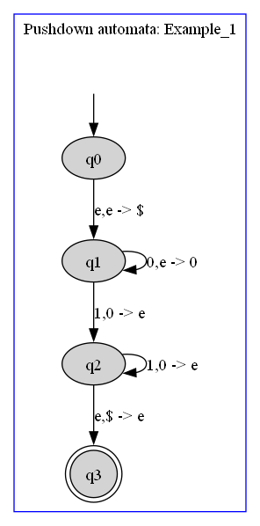

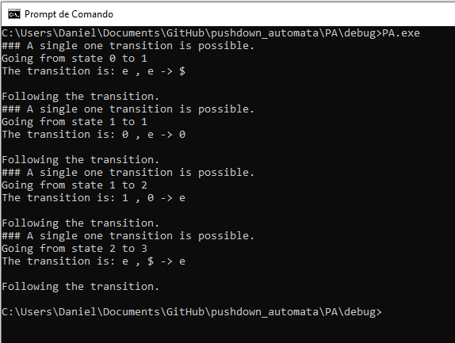

- Language {ww^{R} | w ∈ {0,1}*}

Test cases:
Test ID | Word | Expected result | Obtained Result
1 | 00 | Accept | Accepted
2 | 0110 | Accept | Accepted
3 | 010010 | Accept | Accepted
4 | 01 | Reject | Rejected
5 | 001 | Reject | Rejected
6 | 010 | Reject | Rejected
7 | 0101 | Reject | Rejected

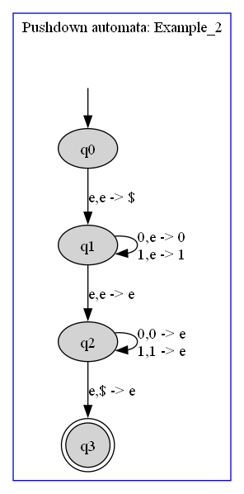

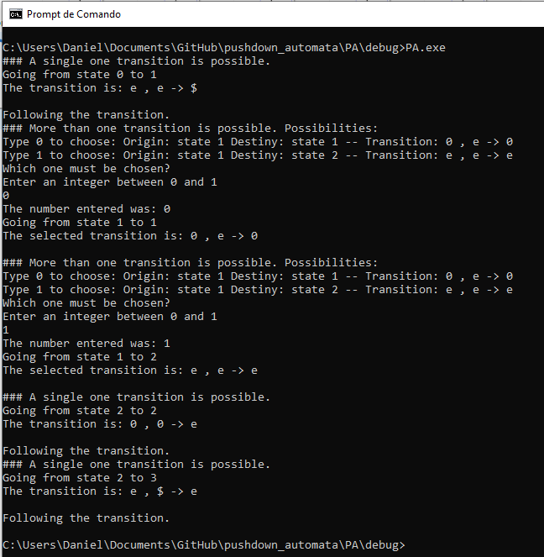

- Language {0^{i}1^{j}2^{k} | i=j ou i=k com n >= 1}

Test cases:
Test ID | Word | Expected result | Obtained Result
1 | 012 | Accept | Accepted
2 | 001122 | Accept | Accepted
3 | 000111222 | Accept | Accepted
4 | 01 | Accept | Accepted
5 | 02 | Accept | Accepted
6 | 0012 | Reject | Reject
7 | 011222 | Reject | Rejected

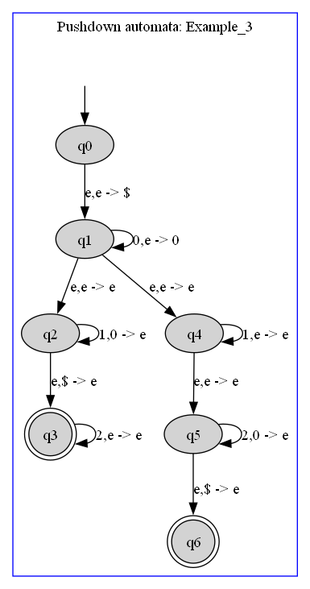

- Language {0^{n}1^{n} | n >= 0}.

Test cases:
Test ID | Word | Expected result | Obtained Result
1 | 01 | Accept | Accepted
2 | 0011 | Accept | Accepted
3 | 000111 | Accept | Accepted
4 | 0 | Reject | Rejected
5 | 1 | Reject | Rejected
6 | 001 | Reject | Rejected
7 |  | Accept | Accepted

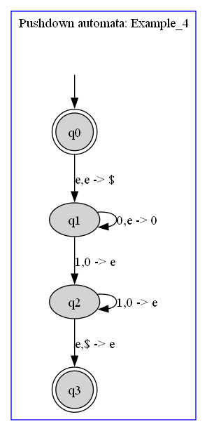

- Language {w ∈ {a,b}* | w=a^{n}b^{n} ou w=b^{n}a^{n} com n >= 0}

Test cases:
Test ID | Word | Expected result | Obtained Result
1 |  | Accept | Accepted
2 | ab | Accept | Accepted
3 | ba | Accept | Accepted
4 | aabb | Accept | Accepted
5 | bbaa | Accept | Accepted
6 | aab | Reject | Rejected
7 | abaa | Reject | Rejected

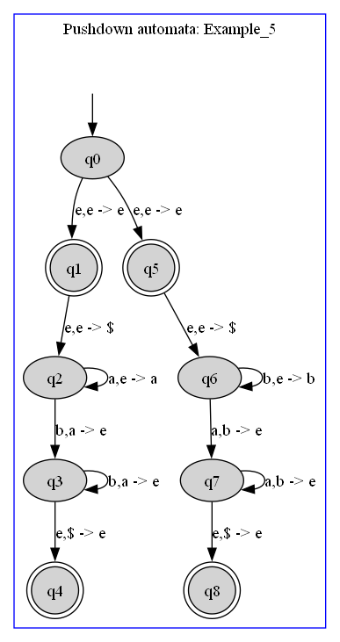

- Language {w ∈ {a,b}* |the quantity of ‘a’ symbols is equal to the quantity of ‘b’ symbols}

Test cases:
Test ID | Word | Expected result | Obtained Result
1 |  | Accept | Accepted
2 | ab | Accept | Accepted
3 | ba | Accept | Accepted
4 | aabb | Accept | Accepted
5 | bbaa | Accept | Accepted
6 | aab | Reject | Rejected
7 | abaa | Reject | Rejected

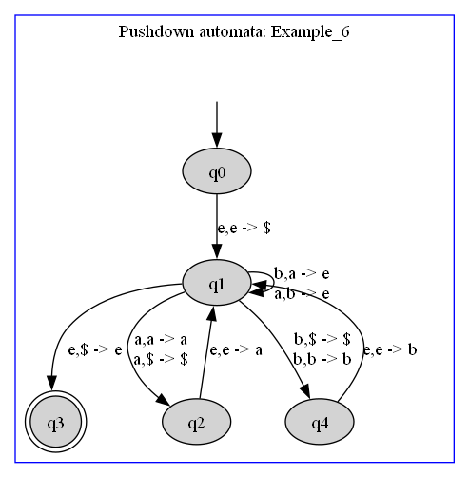

- Language 𝐿 = {𝑎^{𝑛}𝑏^{𝑚}𝑎^{𝑛+𝑚}|𝑛 ≥ 0, 𝑚 ≥ 0}

Test cases:
Test ID | Word | Expected result | Obtained Result
1 |  | Accept | Accepted
2 | abaa | Accept | Accepted
3 | aabbaaaa | Accept | Accepted
4 | ab | Reject | Rejected
5 | aba | Reject | Rejected
6 | ba | Accept | Accepted
7 | baa | Reject | Rejected

